Bash scripting

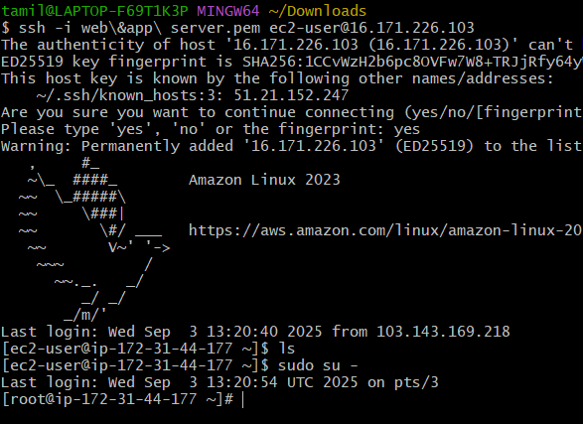

Create a file inside how to write vi.test.bash, for example   
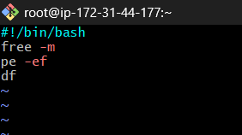  
then save it and execute ./ test.bash

First we need to give permission because there is no permission   
chmod 777 test.bash for permission   
whatever I gave inside file I able to see the output

creating a commands file for executing 6   
script commands:

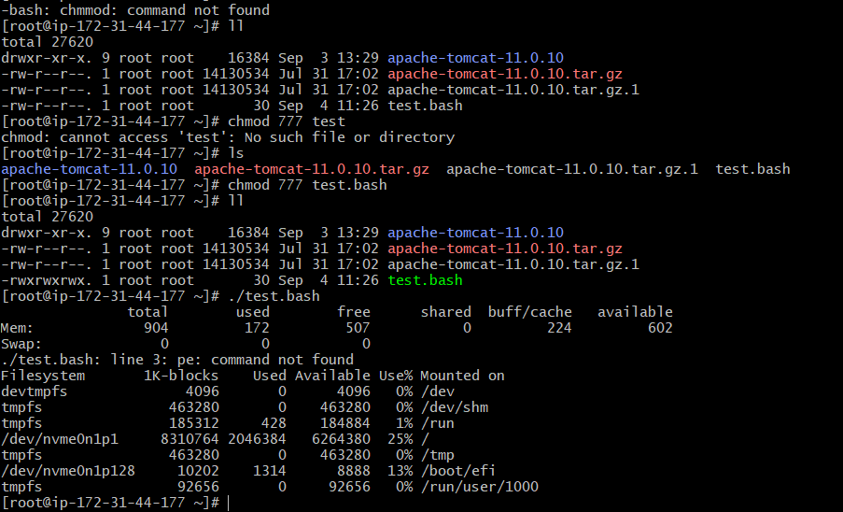

Check the current directory whether its root or bash

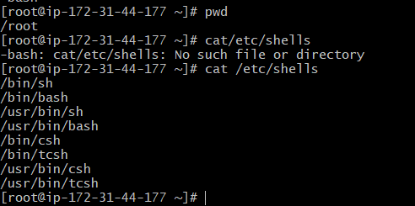

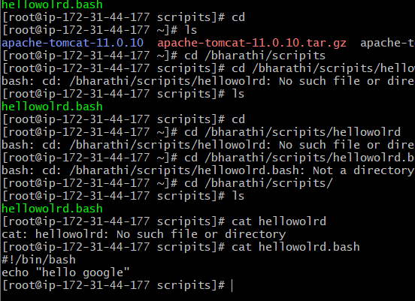

Sample file output

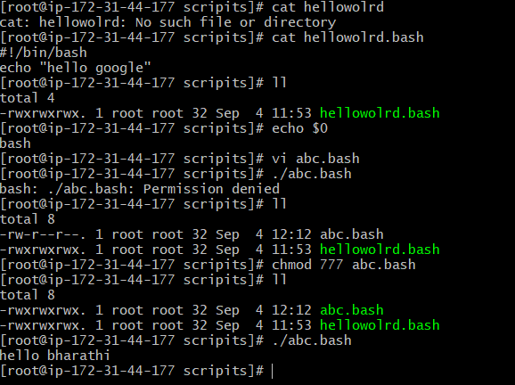  
using the cat file, we can see what is in the file

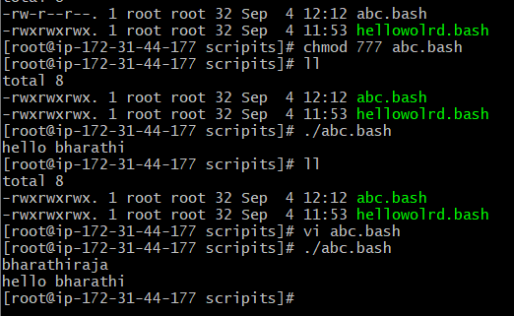

Print sample a file

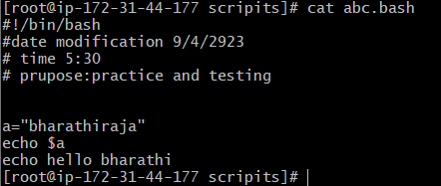

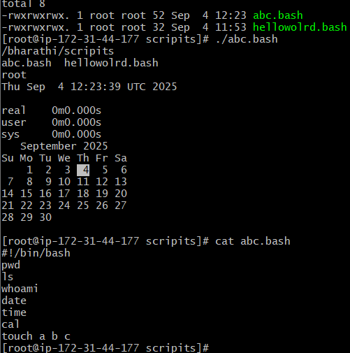

We can add echo in the above and below lines   
it will give the output with providing space  
using variables

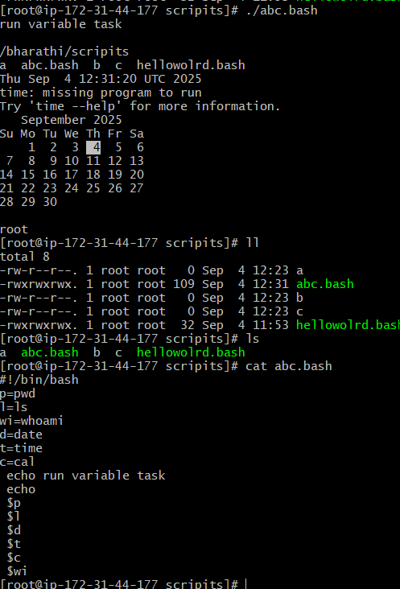

Task 1

Create a file and executing file

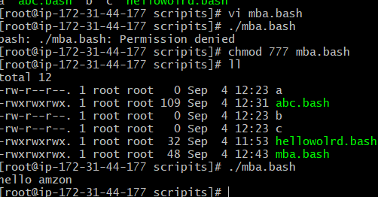

Creating a file vi.var.bash  
this concept read from user & execute

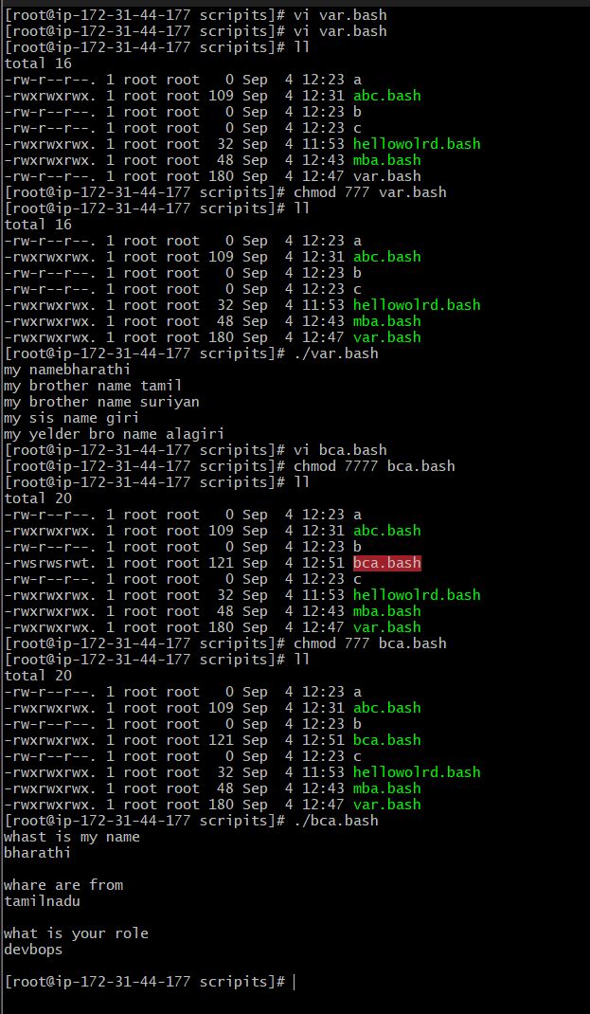

**If we will do to execute individual commands   
the output shows as**

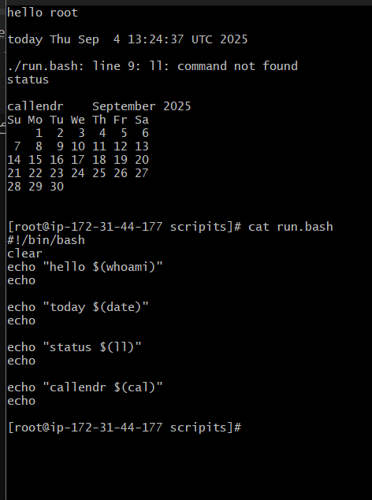

Defining Tasks  
#!/bin/bash  
# Define small tasks  
Pwd- Here it shows the present working   
directory  
Ls- list of files  
Whoami – it has given root directory  
Date – It has given present date and time  
Cal- it has given calender

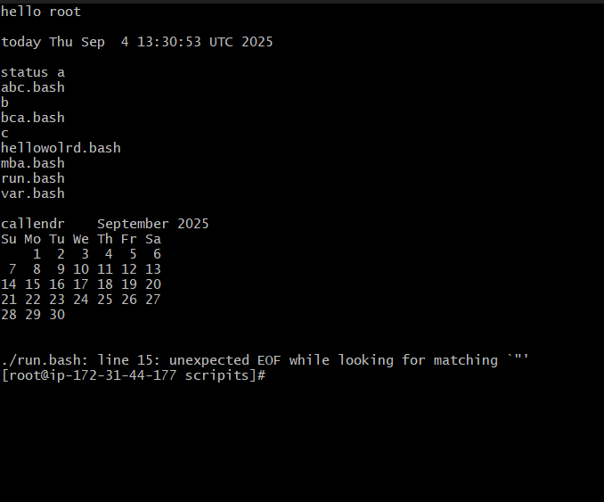

This is a file name change

